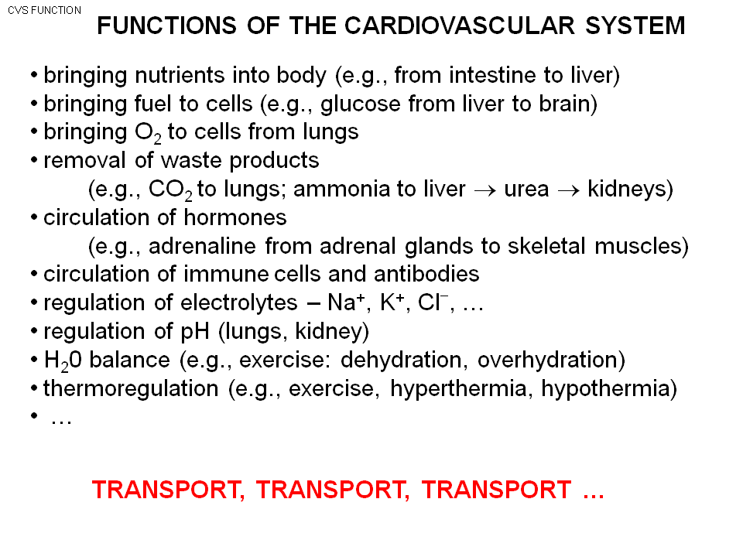
- Absorb nutrient from intestine/gut than transport by blood
- Ex: brain need glucose as fuel and this is transported by cardiovascular system
- Muscle need O2, they are transport from lungs to the heart sent to artery…..
- Remove the waste, ex : breath out air ( CO2) as waste product
- Hormone (definition: chemical made in one organ and than transported to another organ to act) ex: exercise ----activate sympathetic nerves system, (include adrenal gland to make adrenaline than it is release to the blood and make the heart pump faster.) transported by cardiovascular system.
- Immune system: Ex: Cut finger, finger get infected => the antibody, white cell move to the site to fight. The antibody is not made in the skin, they ae transported in blood to skin.
- PH: ph in body is control in a vey narrow range (about 7.4.) The lung, kidney and several organs interact to control the PH inside the body.
- H2O: cardiovascular involve, when exercise at the high level, you lost water (sweat). This involve the cardiovascular system
- Thermoregulation. 1) Exercise; generate heat, body temperature increase. Loose heat by the surface of body. Heat is transported through the blood to the surface of the body to be lost. 2) extreme cold, hypothermic, shut the blood away from skin to not loose heat.
- Cardiovascular system is all about: TRANSPORT the blood around body.
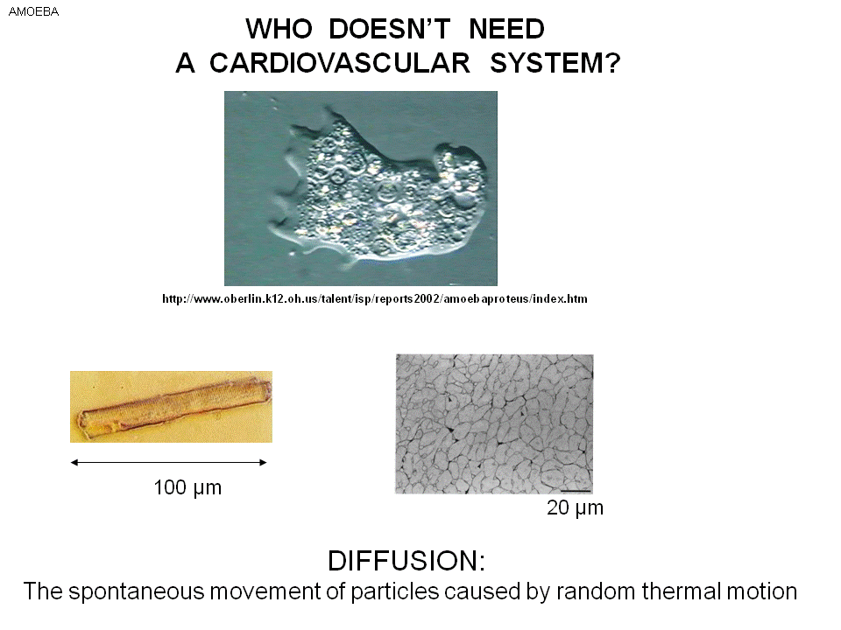
-Bacteria, Amoeba: O2 diffusion, O2 move into the animal (inside have lower O2 molecule, the flow) Co2 diffuse out of the animal. Envelop to grab food. It is small enough that do not need cardiovascular system, diffusion will be enough.
-left bottom: single cardiac cell. This is also very small can get O2 by diffusion.
-right bottom: small black things surrounding cell are the capillaries, each cell is line by tiny vessels full with high oxygen concentration. The heart need a lot of Oxygen and generate a lot of waste product. It need to be close to the blood vessels to bring the right stuff to cell and get rid of waste. This is process of diffusion (O2 /Co2. ) in the short distance.
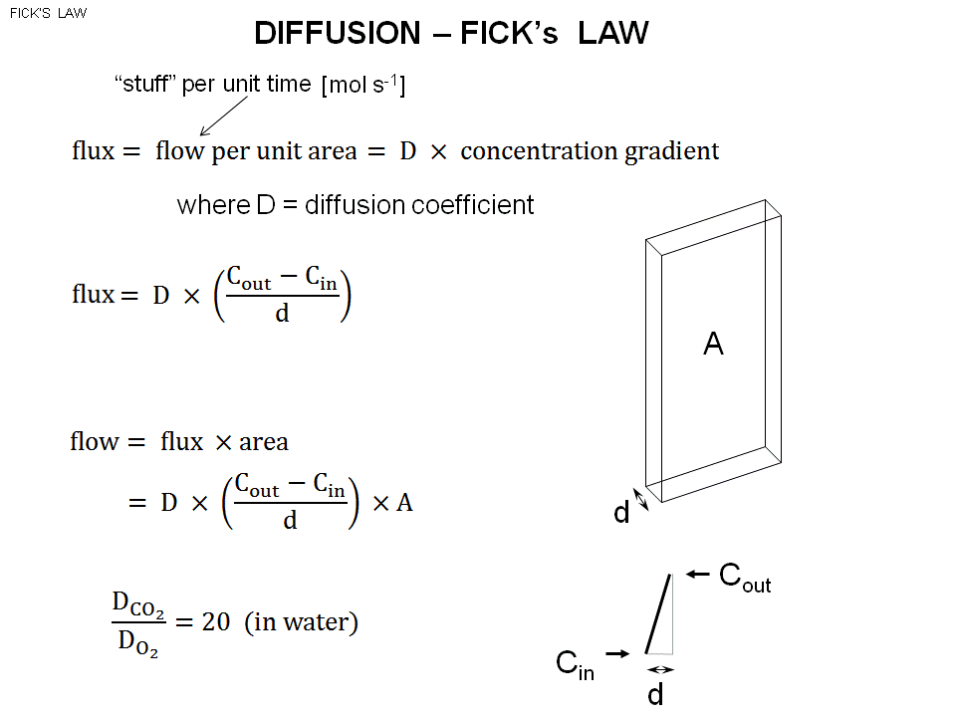
Fick’s law, is the law govern diffusion.
Say the square is a piece of membrane of cardiovascular cell with cross section A, and thickness D.
- O2 will cross the membrane and move from outside to inside of the cell.
- How to measure the stuff ? ex: mol as the amount. => how many mols move across the membrane per unit time.
- Flux is direct proportional to concentration gradient.
- Gradient : special change of a sample ( concentration gradient: spatial change of concentration)
- Fick’s Law => D (diffusion constant ) *concentration gradient ( spatial rate of change in variable = how quickly is that variable changing with distance ex: how quickly the concentration is changing through distance)
- concentration gradient : (Cout -Cin ) /d -------- (The slop of line (delta Y /x) )
- Cout – Cin is the concentration difference. (Cout -Cin ) /d is the concentration gradient.
- Concentration gradient is not concentration difference, is the difference divided by distance.
- Flow = flux *area => D* ((Cout -Cin ) /d )*A
- Therefore the flow : Proportional to diffusion constant and cross section area and Concentration gradient.
- In alveoli : large surface area , the fix law for O2 and Co2 flow cross. ( 200ml/ minute is the average consumption of O2) => maximize the flow.
- In alveoli, capillary and alveoli wall is thin, the concentration gradient is large ( small d)
- With large area, maximize the flow.
- Flux is independent to area, flow is directly proportional to area.
- Substance: Diffusion coefficient for Co2 is 20 times larger than O2. Under same concentration gradient, Co2 can be 20 times easily diffuse than O2. ( For the same concentration gradient, CO2 will be larger concentration)
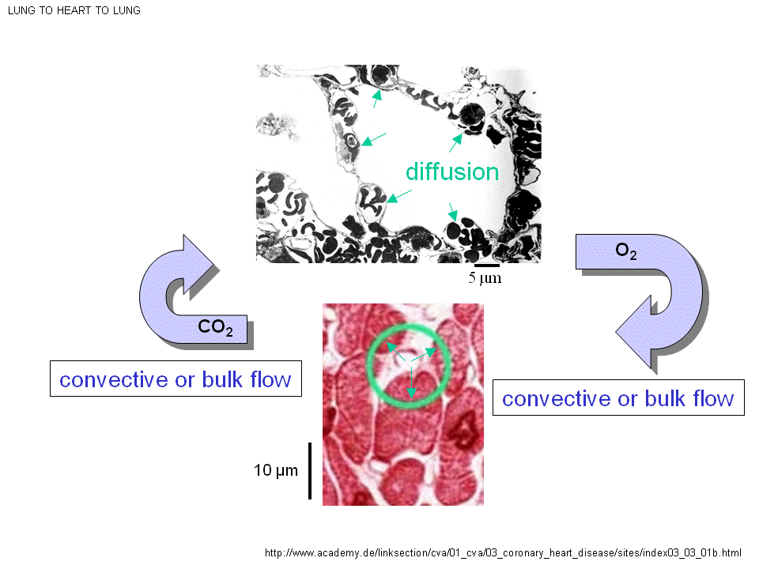
upper: alveolus in the middle of alveolus is air jus inspired. The wall is formed of capillaries. Inside the blood vessel (black colored) is the RBC. You breath in bulk flow bring in oxygen, O2 move by diffusion through alveoli membrane than to interstitial space than through capillary walls. The capillary wall is one cell thick. flow through the fluid portion of blood: plasma cross membrane of RBC. Go into The RBC bind to hemoglobin.
- The small distance make the concentration gradient large.
- All the process is diffusion (O2 move from higher concentration to lower concentration)
- The blood that flow back to the lung is deoxygenated (wasted be sent back to be oxygenated)
- The capillary (red rings ) around the muscle cells, how does the oxygen get to thumb? It moves by the process of diffusion from the lung to the RBC. Red cell is pump all over the body and end up in the muscle capillary. ( This is mot diffusion, this is bulk flow or convective flow) Bulk of blood from the level of lung and that moves back to the heart and end up to the finger. If there is a red cell in capillary. The difference of O2 concentration between muscle cell and RBC ( with distance = concentration gradient)
By fick’s law. O2 move out of Red cell and move through the blood plasma move across the wall of capillary move through the interstitial space move across muscle cell membrane cytoplasm of the muscle cell O2 end up in mitochondria (in the mitochondria to involve in energy production)
- Take a breath , air move as a bulk move down to mouth , trachea, bronchi, alveolar sac ( bulk flow ) ======= Bulk flow, the oxygen go down the alveoli by bulk.
- Diffuse across the aveoli wall, and end up to RBC.
- Convective (bulk) away from the heart up to organ
- O2 Diffuse to the organ to be use, and Co2 is produced here (in muscle)
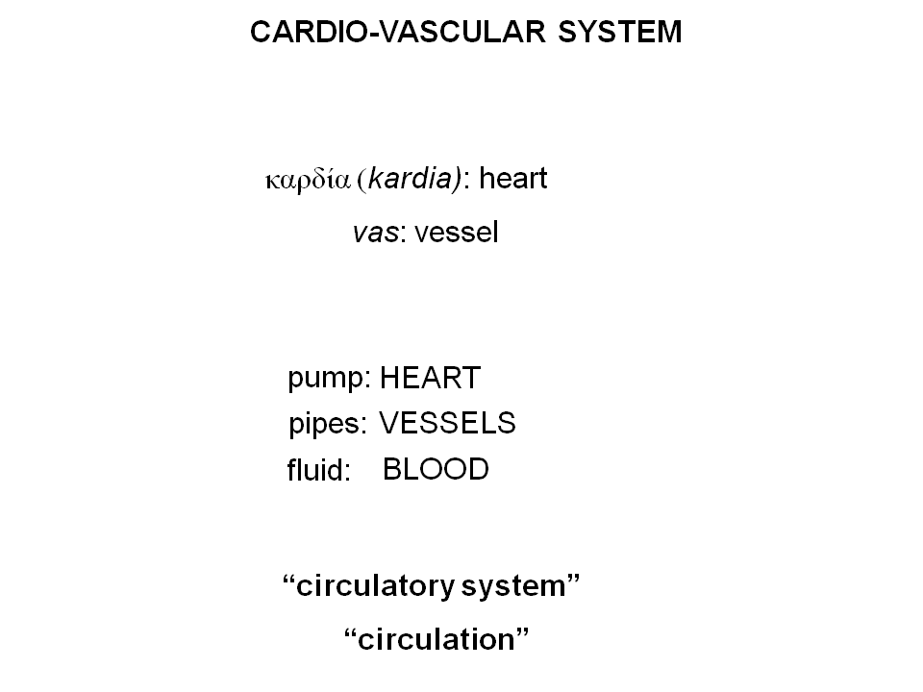
- Co2 move out to blood vessel convective to lung aveolar space (diffusion) breath out , and excrete the Co2

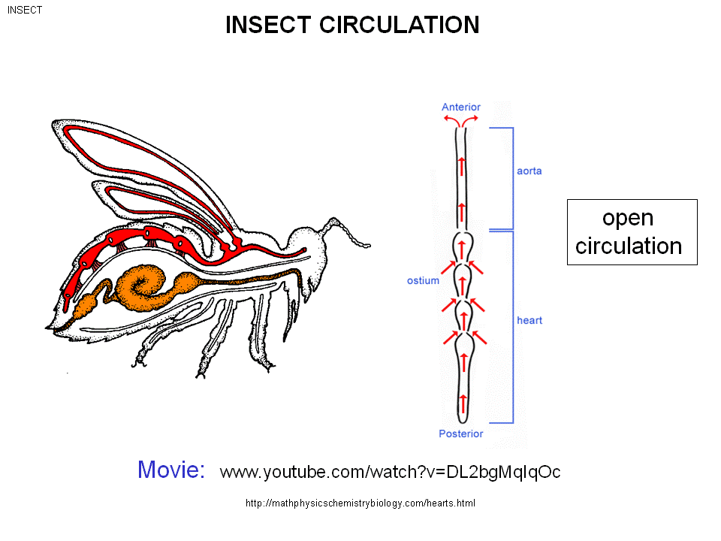
-Insect: open circulation
The vessel along the dorsal aorta, the bumps are the heart of the animal.
- The mussel contract along vessel, and squeeze. Hemolymph move form posterior to anterior.
- The vessel have a open end, the Hemolymph go back and bath all the organs. Hemolymph go back to vessel through holes(ostium), and be pump.
- Open circulation.
- In closed circulation, fluid is always kept.

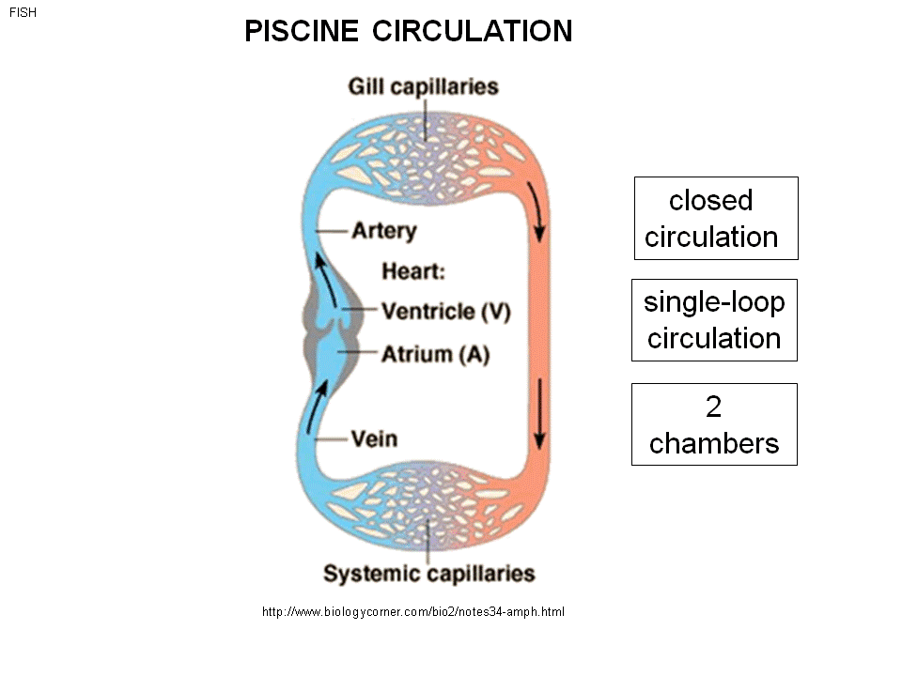
- Fish : closed circulation single loop ( blood in heart or vessel, always )
- - Atrium and Ventricle. Atrium pump and squeeze blood to ventricle, and sent blood to gills of the animal. This is where O2 and Co2 exchange with outside world.
- Blood: deoxygenated
- Red: Oxygenated
- : Oxygenated blood go to systemic circulation ( systemic = capillaries everywhere in the body except the gill ) The oxygen is than pump back.
- This is a single loop circulation with two chambers of heart.

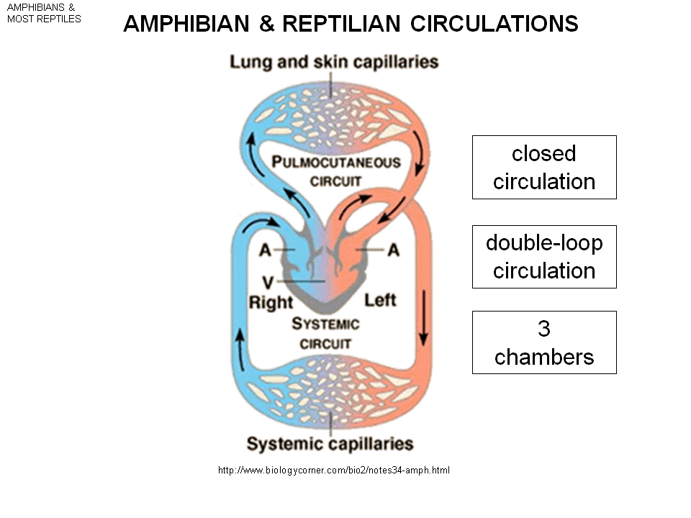
Amphibians (and most reptiles)
-closed circulation
-2 loops :pulmocutaneous---supply to the lungs and skin, systemic to the body
- 3 chambers
- In frog: 3 chambers: Left atrium/ right atrium/ ventricle => Left and right atrium pump simultaneously in to the single ventricle. (the separation flow stream allow deoxygenated and oxygenated blood to separate.) : this sent to both lungs and body. Frog can breath through skin. The blood from ventricle goes to both the lungs and skin to gas exchange, and turn form blue to red. This blood is brought back to the left atrium. At the same time , blood is also pump from the ventricle out to the body to be used.
-right and left atrium contract simultaneously and the blood go to ventricle and the blood go to the whole body

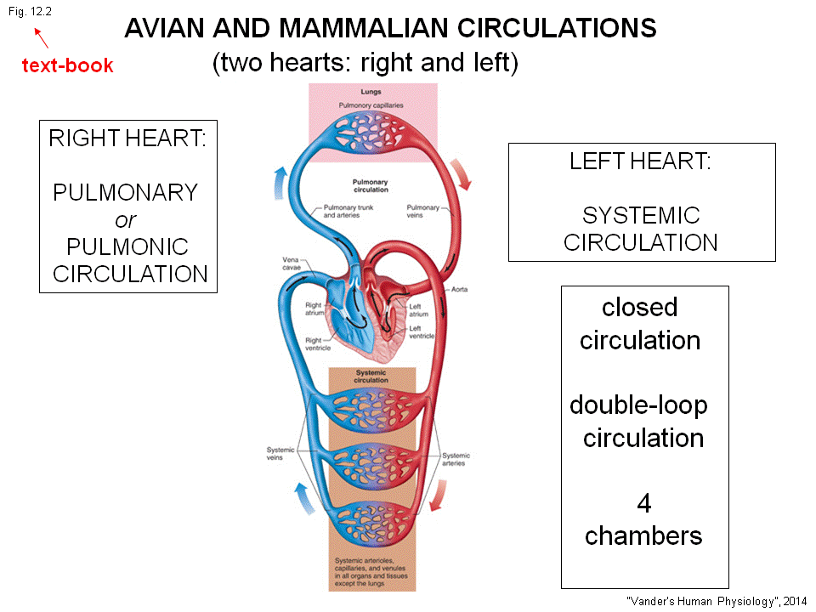

Birds/Mamammals(
- Closed
- 2 loops –pulmonary and systemic loop
- 4 chambers. Left vs reight ventricle
- So we have four hearts
- Left/right heart –The right heart: pulmonary circulation go to the lungs. Left heart: systemic circulation – go to the body.
- Right ventricle blood to the lungs come to the left atrium Left ventricle body deoxygenated right atrium right ventricle to the lungs (a loop)

